

Mohammad Ali Jinnah University

Chartered by Government of Sindh - Recognized by HEC

**Lab Assignment 1**

**Name:** Muhamad Fahad

**Id:** FA19-BSSE-0014

**Subject:** Software Engineering Lab (CS 3111)

**Section:** CM

**Teacher:** Sir Abdul basit

**Date:** Thursday, October 15, 2020

**Q1:** Write down the Importance of Software Engineering in the Real world?(2 points)

**Answer:**

**Importance of Software Engineering**

As we all know that software industry is one of the rapidly growth industry and now for any government it’s the back bond/larger assets production. If a person need to do a work /Startup a new business/industry they need some specific software for they used so in short they want a specific function/method or feature in the software so its compulsory for a developer to understand there requirement of the real world/customer. For understanding the requirement, a Software Engineer learn many course and then do many practice before starting a profession Job. Software Engineering is way to save the time, resource and divide the work so you divide the load. The Customer will be able to see the output of the before developer start the work mean the documentation/UML/flowchart or designed structure of the software.

**Q2:** **What do you understand by UML? Why do we use UML in the Software industry?**

**Answer:**

**Definition:**

UML (Unified Modeling Language) is the way to explain the problem to even a person who doesn’t have any programming background.

**OR**

UML is the graphical representation of the problem/software or program it will save the time of the developer and customer will be able to change any part/feature in the software.

**Uses:**

It will save the time of the developer, in understanding the problem. It will also provide the solution (Structure of Software). A developer even a customer also need a UML because it help User to understand what developer is going to made or what change they may have to do. UML is need as a communicate language between User and developer.

**Q2:** **Why is the UML necessary?**

**Answer:**

UML is necessary because in this way the developer bound the customer that before starting (Coding) after giving requirement. Developer may show the customer a structure and flow of the software that may indicate the feature of the software now if the client may want any changes the developer can do. But if UML is not use and when the software provide or giving to the client and then they say there are some feature which are missing so the software, time or recourse all go in waste so software industry introduce UML and may set some Standard for the world.

**Q4: edraw Max is a software modeling platform that supports UML?**

**Answer:**



Open Google and Search e draw max download. Click on the first link







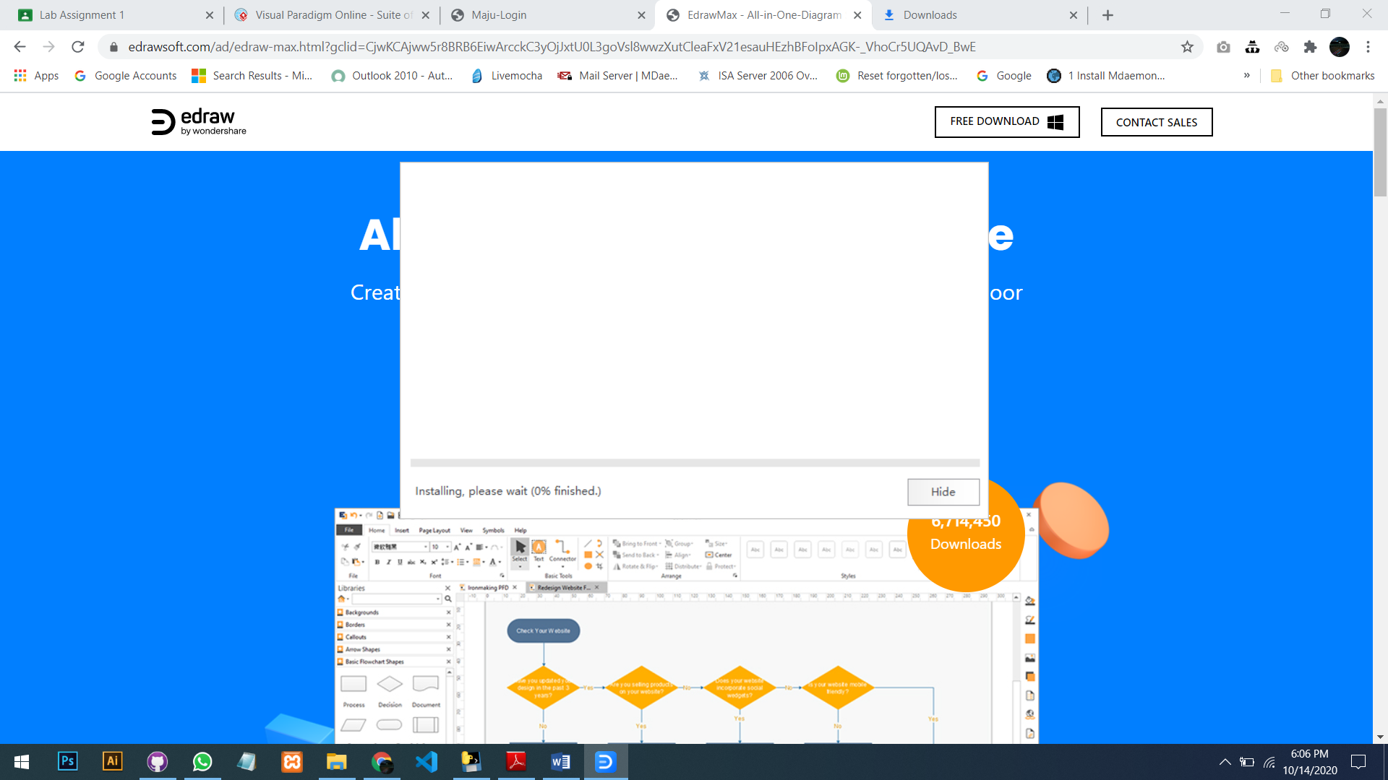

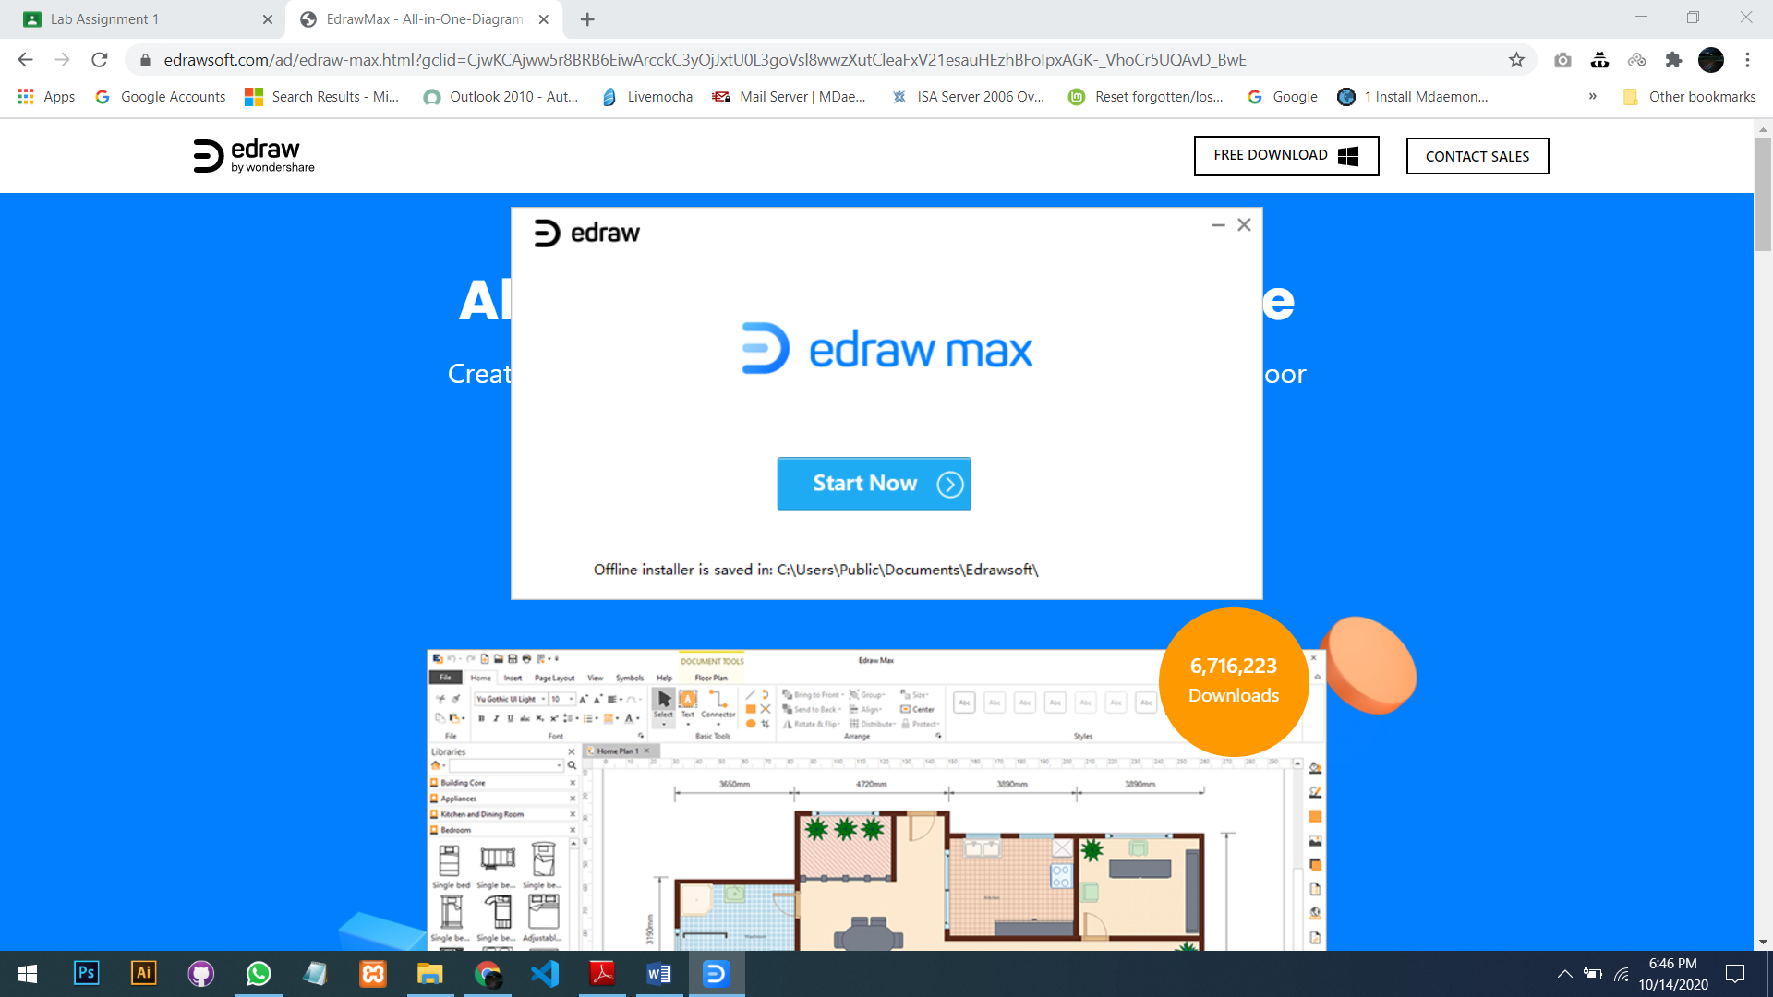

As the installation, complete click on start button.

**Bonus Question:**

**Draw the activity diagram of your daily routine ( breakfast , university classes , sports, lunch ,dinner ) using Visual Paradigm Online and share the screen shoot**

**Answer:**

